**D.K.T.E. Society’s Textile and Engineering Institute, Ichalkaranji.**

**(An Autonomous Institute, Affiliated to Shivaji University, Kolhapur)**

DEPARTMENT OF INFORMATION TECHNOLOGY

2019-2020



**Project report on**

**IOT based soil classification and crop prediction*.***

**Under the guidance of**

Prof. T. I. Bagban

**Group Members:**

1.Parimal Rahul Gaurkhede 16UIT12011XX

2.Priti Prashant Kurdekar 16UIT11027XX

3.Riddhi Rajesh Shah 16UIT11048XX

|  |  |  |
| --- | --- | --- |
| 4.Susmita Shankar Udupi    5.Shruti Shatrughna Chandanshive |  | 16UIT41055XX  19UIT651 |

Prof. T. I. Bagban Prof. (Dr.) P. V. Kadole Prof. (Dr.) D. V. Kodavade

**[Project Guide]** **[Director]** [**Head of Department]**

**D.K.T.E. Society’s Textile and Engineering Institute, Ichalkaranji.**

**(An Autonomous Institute, Affiliated to Shivaji University, Kolhapur)**

Department of Information Technology

CERTIFICATE

This is to certify that

|  |  |  |  |
| --- | --- | --- | --- |
| 1.Parimal Rahul Gaurkhede |  |  | 16UIT12011XX |
| 2.Priti Prashant Kurdekar |  |  | 16UIT11027XX |
| 3.Riddhi Rajesh Shah |  |  | 16UIT11048XX |
| 4.Susmita Shankar Udupi |  |  | 16UIT41055XX |

5.Shruti Shatrughna Chandanshive 19UIT651

have successfully completed the mini project work, entitled,

**IOT based soil classification and crop prediction*.***

in partial fulfillment for the award of degree of Bachelor of Technology in Information Technology. This is the record of their work carried out during academic year 2019-2020.

Date: Place: Ichalkaranji

Prof. T. I. Bagban Prof. (Dr.) D. V. Kodavade

**[Project Guide]** [**Head of Department]**

Prof. (Dr.) P. V. Kadole

**[Director]**

**DECLARATION**

We the undersigned students of B.Tech Information Technology declare that, the field work report entitled **IOT based soil classification and crop prediction**written and submitted under the guidance of **Prof. T.I.Bagban** is our original work. The empirical findings in this report are based on the data collected by us. The matter assimilated in this report is not reproduction from any readymade report.

Date:

Place: Ichalkaranji.

**Members** Signature

1. Parimal Rahul Gaurkhede
2. Priti Prashant Kurdekar
3. Riddhi Rajesh Shah
4. Susmita Shankar Udupi
5. Shruti Shatrughna Chandanshive

**ACKNOWLEDGMENT**

At the outset we would like to acknowledgement our grateful thanks to our guide Mr. T. I. Bagban from the department of Information Technology for his valuable guidance and suggestion regarding our project “IOT BASED SOIL CLASSIFICATION AND CROP PREDICTION”. We would like to express our thanks to Dr.D.V.Kodavade sir, Head of Information Technology department for his great moral support.

We are thankful to Dr. P.V. Kadole, honourable Director, Textile and Engineering Institute, Ichalkaranji, for providing necessary facilities for completion of this work.

Last but not least, we would like to thank our all staff and friend for their keen advice and support.

* GAURKHEDE PARIMAL RAHUL
* KURDEKAR PRITI PRASHANT
* SHAH RIDDHI RAJESH
* UDUPI SUSMITA SHANKAR
* CHANDANSHIVE SHRUTI SHATRUGHANA

**INDEX**

**CONTENTS PAGE**

1. **Introduction 8**
   1. Problem Definition
   2. Need of the project with motivating example
   3. Objectives of project
   4. Scope & limitations of project
   5. Timeline for project
2. **Literature Review 13**
   1. Technology review
   2. Literature review
3. **Requirement Analysis**

###### 3.1 Functional Requirements 15

3.1.1 User Interface requirements

3.1.2 Hardware interface requirements

3.1.3Communication protocol requirements

###### 3.2 System Requirements 16

3.2.1 Hardware Requirements

3.2.2 Operating System Requirements

3.2.3 Application or Web server requirements

3.2.4 Database server Requirements

3.2.5 Tools and Technologies Requirements

1. **System Design 18**
   1. Architectural Design
   2. User Interface Design
   3. Algorithmic description of each modules
   4. Dataflow Diagram
   5. Class Diagram
   6. Sequence Diagram
   7. Use Case Diagram

**5 Implementation 26**

5.1 NodeMCU

5.2 AWS cloud services

5.3 Amplify Framework

**6 Software Testing 28**

6.1Unit test cases generation and its testing reports

6.2Integration test cases generation and its testing reports

**7 Screenshots 30**

**8 Performance Analysis 36**

**9 Application 37**

**10 Conclusion 38**

**11 Installation guide and User Manual 39**

**12 References 40**

**ABSTRACT**

In India almost 70% of population are dependent on agriculture and are involved in crops production and related activities. According to the data survey 2015, it was found that India is lacking behind in the rice production from many countries. There is drastic increase in population and at the same time crop productivity remained same, hence there is a need to fulfill the increased crop demand. In order to meet the high yield of crop there is a need to use advanced technology in the field. Smart farming and precision farming are modern ways of farming. We are developing a system which is based on smart farming and precision farming using The Internet of Thing (IoT), sensors and controllers to capture soil and environment parameters and Artificial Intelligence and Machine learning to predict the types of crops suitable for cultivation. This system is a recommendation engine that makes recommendation based on type and quantity of nutrients present in the soil, weather condition present in the farm. The data is collected through the sensors present in the farm. PH sensor, Soil Moisture, Air Humidity and Air Temperature these sensors are used in this system. This sensor data is pre-processed and naive bayes algorithm is applied to classify the soil. We applied various classification algorithm for crop recommendation and found that liner learner using sagemaker has the highest accuracy score. This whole system is integrated with android mobile application which shows the list of crops to be cultivated in the respected class of soil.

## 1. INTRODUCTION

1. **Problem Definition**

To develop a system to classify soil using soil parameters and predict crop using soil and weather condition.

**Need of the project with motivating example**

India is a land of agriculture and agriculture plays a vital role in the Indian economy. Agriculture is considered as a primary means of livelihood for about 58% of the rural India. The green revolution which introduced various high yielding seeds and fertilizers undoubtedly led to increase in crop. About 70% of the population are involved in crop production and related activities. Despite the overwhelming size of the agricultural sector, however, yields per hectare of crops in India are generally low compared to international standards. Even though agriculture accounts for as much as a quarter of the Indian economy and employs an estimated 60 percent of the labor force. Still the Variation of Ecosystem in the Agriculture Land of India has leads to Growth of Various Crops.

But Due to the Current Economic and Social Conditions, the Agriculture Sector is degrading its performance and other financial sectors are getting importance.

Following are the consequences of degrading agriculture sector

* Food Demands of Urban Cities are not satisfied.
* Below Priority Level People don't get quality Pulses and Vegetables.
* Malnutrition and Starvation in various states of the country.
* Young farmers are not getting proper guidance for the cultivation in farming.
* Appropriate use of the soil is not considered leading to loss of soil fertility
* Extreme weather conditions leads to huge Loss within the farms.
* Wastage of the Certain Crops does not satisfy the needs and Desire of the farmers.

1. **Objectives of the project**

* To study of different types of soils and crops suitable for a type of soil.
* To identify and select different types of sensor to read the parameter values suitable for identifying different soil types.
* To identify and select different types of sensors to read the environment parameters suitable for identifying different types of crops for the given type of soil.
* To create classification model to classify soil for given soil parameters.
* To create prediction model to classify crops for given environmental parameters and soil type.
* To train and test soil classification and crop prediction models.
* To deploy the system on suitable cloud platform.
* To build android app for farmers to interact with the system.

1. **Scope & limitations of the project**

**Scope**

* Help in Decision Making for the Farmers which crop to be produce with the respective conditions
* Farmers will known its appropriate condition for the soil health.
* It help Government Agricultural Organization to know the actual Soil
* Increase in the Crop Production raises to Economic Benefit in Agriculture Sector.

**Limitations**

* Dynamic Nature of Soil
* Changing Weather Condition for the Long-Time
* Uncertainty within the Environmental Factors such as Rainfall, Drought Conditions

1. **Timeline for Project**

|  |  |  |  |  |  |
| --- | --- | --- | --- | --- | --- |
| Sr. no | Work | Start Date | End Date | Work in hrs | Status |
| 1 | Area Finalization | 22/7/19 | 28/7/19 | 30 hrs | Completed |
| 2 | Information Gathering & Literature Survey | 28/7/19 | 12/8/19 | 30 hrs | Completed |
| 3 | Design,Analysis and HW Configuration | 14/8/19 | 5/9/19 | 60 hrs | Completed |
| 4 | Module 1: Registration and Login | 15/9/19 | 5/10/19 | 20 hrs | Completed |
| 5 | Module 2: Connect to IOT Device | 5/1/20 | 15/1/20 | 30 hrs | Completed |
| 6 | Module 3: Receive data to Android | 15/1/20 | 25/1/20 | 25 hrs | Completed |
| 7 | Module 4: Soil Classifier | 26/1/20 | 7/2/20 | 30 hrs | Completed |
| 8 | Module 5: Crop Predictor | 9/2/20 | 16/2/20 | 25 hrs | Completed |
| 9 | Module 1 Testing | 18/2/20 | 25/2/20 | 12 hrs | Completed |
| 10 | Module 2 Testing | 26/2/20 | 5/3/20 | 20 hrs | Completed |
| 11 | Module 3 Testing | 6/3/20 | 10/3/20 | 15 hrs | Completed |
| 12 | Module 4 Testing | 13/3/20 | 20/3/20 | 16 hrs | Completed |
| 13 | Module 5 Testing | 22/3/20 | 28/3/20 | 18 hrs | Completed |
| 14 | Integration of Module and Testing | 13/3/20 | 14/4/20 | 30 hrs | Completed |
| 15 | Final Documentation |  |  |  |  |

**Cost for Project**

**Hardware**

|  |  |  |  |
| --- | --- | --- | --- |
| Sr . No. | Equipment/Particular | Qty | Price(Rs) |
| 1 | ESP-8266 Wi-Fi Module | 1 | 300/- |
| 2 | DHT 11 Sensor | 1 | 130-/ |
| 3 | Soil Moisture Sensor | 1 | 110/- |
| 4 | Ph Sensor | 1 | 2000/- |
| 5 | Other (Wires, Breadboard, Battery, etc…) | - | 50/- |

Estimated Hardware cost will be approx. Rs. 2590 /-

**COCOMO Model:**

In this project the Cost Estimation based on COCOMO (Constructive Cost Model) the formula for the this Model is follows

Effort = Constant × (Size) scale factor× Effort Multiplier

* Effort in terms of person-months
* Constant: 2.45 in 1998 based on Organic Mode
* Size: Estimated Size in KLOC
* Scale Factor: combined process factors
* Effort Multiplier (EM): combined effort factors

Functional Point Table

The function point range in between 1-10

|  |  |  |  |
| --- | --- | --- | --- |
| Number of FP | Complexity |  |  |
| External User Type | Low | Average | High |
| External input type | 4 | 6 | 9 |
| External output type | 5 | 7 | 9 |
| Logical internal file type | 4 | 6 | 9 |
| External interface file type | 5 | 8 | 10 |
| External inquiry type | 4 | 6 | 8 |
| Total | 33 |  |  |

Conversion of Functional point to Lines Of Code ( LOC )

Total function points = 33

■ Estimated Size – 200 LOC

The basic COCOMO equations take the form

Effort Applied (E) = ab(KLOC)bb [ man-months ]

Development Time (D) = cb(Effort Applied)db [months]

People required (P) = Effort Applied / Development Time [count]

Where, KLOC is the estimated number of delivered lines (expressed in thousands) of code for project. The coefficients ab, bb, cb and db are given in the following table

|  |  |  |  |  |
| --- | --- | --- | --- | --- |
| Software  Project | ab | bb | cb | db |
| Organic | 2.4 | 1.05 | 2.5 | 0.38 |
| Semidetached | 3.0 | 1.12 | 2.5 | 0.35 |
| Embedded | 3.6 | 1.20 | 2.5 | 0.32 |

Organic Mode

EFFORT = 2.4 x (8.12)*1.05 =20.46

Development Time= 2.5 x (3)*0.38 = 3.79

People required = 20.46/3.79= 5 people

## 

## 2. LITERATURE REVIEW

2.1 Technological Review

AWS IoT Analytics

Amplify Framework (Serverless Application)

The Amplify Framework provides a set of libraries, UI components, and a command line interface to build a mobile backend and integrate with your iOS, Android, Web, and React Native apps. The Amplify CLI allows you to configure all the services needed to power your backend through a simple command line interface.

Arduino IDE

Arduino consists of both a physical programmable circuit board (often referred to as a microcontroller) and a piece of software, or IDE (Integrated Development Environment) that runs on your computer, used to write and upload computer code to the physical board.

GitHub

GitHub is a web-based hosting service for software development projects that use the Git revision control system.Source code management (SCM) is used to track modifications to a source code repository. SCM tracks a running history of changes to a code base and helps resolve conflicts when merging updates from multiple contributors.

Git

Git is a free and open source distributed version control system designed to handle everything from small to very large projects with speed and efficiency. Git is easy to learn and has a tiny footprint with lightning fast performance.

AWS IOT Core

AWS IoT Core is a managed cloud service that lets connected devices easily and securely interact with cloud applications and other devices. AWS IoT Core can support billions of devices and trillions of messages, and can process and route those messages to AWS endpoints and to other devices reliably and securely. With AWS IoT Core,applications can keep track of and communicate with all your devices, all the time, even when they aren’t connected.

Amazon Sagemaker

Amazon SageMaker is a fully managed service that provides every developer and data scientist with the ability to build, train, and deploy machine learning (ML) models quickly. SageMaker removes the heavy lifting from each step of the machine learning process to make it easier to develop high quality models.

AWS API Gateway

Amazon API Gateway is a fully managed service that makes it easy for developers to create, publish, maintain, monitor, and secure APIs at any scale. APIs act as the "front door" for applications to access data, business logic, or functionality from your backend services. Using API Gateway, you can create RESTful APIs and WebSocket APIs that enable real-time two-way communication applications. API Gateway supports containerized and serverless workloads, as well as web applications.

Amazon Elastic EC2

Amazon Elastic Compute Cloud (Amazon EC2) is a web service that provides secure, resizable compute capacity in the cloud. It is designed to make web-scale cloud computing easier for developers. Amazon EC2’s simple web service interface allows you to obtain and configure capacity with minimal friction. It provides you with complete control of your computing resources and lets you run on Amazon’s proven computing environment.

2.2 Literature Review

F. Tseng et. al. [4] in their work proposed big data analysis of farms based on Intelligent Agriculture and provide following features: (1) IoT sensors for temperature,humidity, atmospheric pressure, illumination, electrical, conductivity of soil, and irrigation, and (2) a solar power storage system that helps reduce electricity costs; and (3) an XMPP web platform that helps collect information from the IoT sensors. The work conducts big data analysis on the information collected from the Intelligent Agriculture system. The system employs moving average and variance in data cleaning, which cleans out data with more drastic variation. The work applies autocorrelation to compute periodicity while using 3D cluster correlation to conduct behavior analysis of farmer actions such as application of fertilizer or pesticide. The study takes looks into environmental factors to assess whether a crop is suitable for a farm; it also takes global warming into consideration.

S. Liu et.al [5] in their work discussed IoT and cloud based monitoring systems for agriculture management.The study uses design of combining Internet of Things, cloud computing, big data in modern agriculture. In addition, a hybrid data storage scheme based on NoSql database DynamoDB, relational database Oracle, and le object storage Amazon S3 are also used.

R. Priya et al[6] in their work proposed an efficient crop recommendation system. The work uses naïve bayes algorithm for crop recommendation. The system is claimed to be scalable as it can be used to test on different crops. The system from the yield graphs finds out the best time of sowing, plant growth and harvesting of plant. The model is extensible to find the yield of every crop and for pesticide recommendation and can be modified to suggest about the fertilizers and irrigation need of crops.

## 3.REQUIREMENT ANALYSIS

#### 3.1 Functional Requirements

1.User Interface Requirements

* Login Panel -for Authentication
* Adding Current Location
* Showing Soil Properties
* List of Crops that can be Grown in the Respective Soil

2.**Hardware Interface Requirements**

* Microcontroller Unit with Wi-Fi Module

3.Communication Protocol Requirements

* To establish the communication with AWS cloud computing the Private key and Public key required for the asymmetric encryption.
* To establish the connection of IOT Device with the IOT server then we have to establish through TLS protocol and CA certificate.
* MQTT subscribe and Publish Model
* Programming the NodeMCU requires Arduino IDE for connecting to Microcontroller Unit.

##### 3.2 System Requirements

1.Hardware Requirement

* AWS EC2 Virtual Machine oRam:8GB

oMemory:20GB

* NodeMCU

Hardware Specification Type: Single-board Microcontroller

Power Voltage:3V,5V (Used with 3.3V Regulator which inbuilt on board)

**IDE used:** Arduino IDE

2.Operating System Requirement

* NodeMCU Operating System: XTOS
* CPU: LX106
* Memory: 128kBytes
* Storage: 4MB
* Power: USB

3.Application or Web Server Requirement

* Minimum Configuration Requirement
* For 3 Concurrent Users
* CPU: Intel Core 2 (2 GHZ)
* RAM:4GB

4.Database server Requirement

* Database Server: MySQL server
* Minimum no of instances:5
* Minimum Database Server:10GB

5.Tools and Technological Requirements

* Jupyter Notebook
* Android Studio
* AWS IoT core
* AWS Cloud Services
* Arduino IDE
* AWS Amplify Framework

### 4. SYSTEM DESIGN

**Architecture Design**

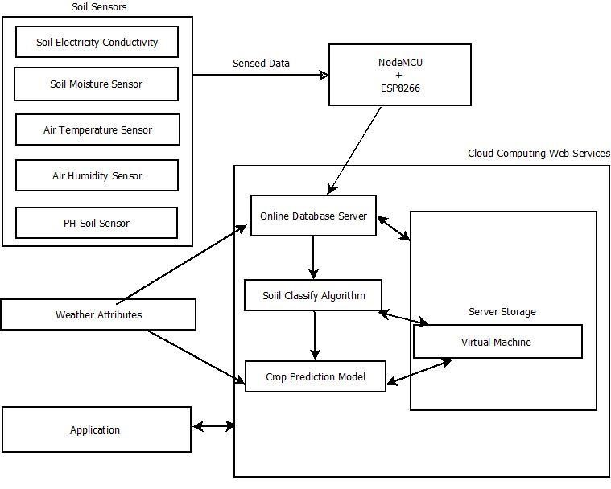

**User Interface Design**

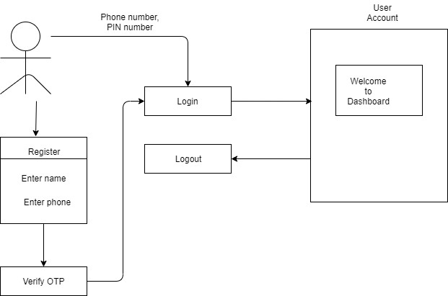

**Algorithmic Description of each modules**

**Module 1- Registration & Login**

Input: Name of the user, Phone no, Pin

Output: Successful Registration & Login

Description: It is used for Authentication of User

**Module 2- Connect to IOT Device**

Input: Sensors Data

Output: JSON Format

Description: It used to collect and transmit the Sensed Data through MQTT Subscribe-Publish Model.

**Module 3- Receive Data to Android**

Input: Data from IOT Server

Output: Structure Schema

Description: The Module used to send the IOT data to Android Application. Further used the data for ML Processing.

**Module 4 - Soil Classifier**

Input: Sensors Reading

Output: Classified Soil

Description: Classification Algorithm that used to classify the soil Taxonomy Class and its respective base Class and Soil Texture.

**Module 5- Crop Predictor**

Input: Sensors Reading & Soil Texture

Output: List of Crops

Description: Module used to predict the grown crop in the respective soil.

**Dataflow Diagram**

Application

USER

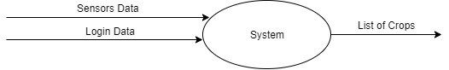

Fig a. DFD Level 0

Fig

b

. DFD Level

1

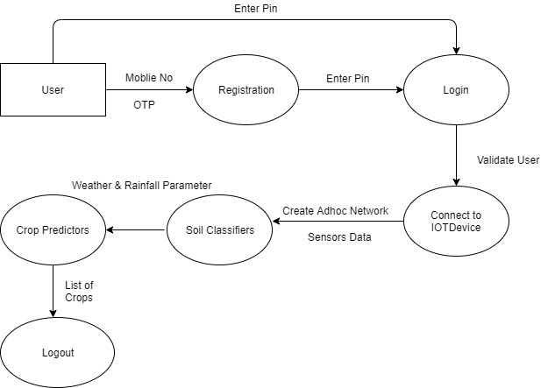

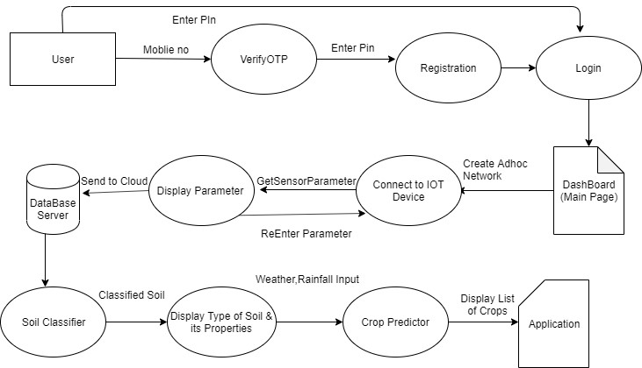

Fig c. DFD Level 2

**Class diagram**

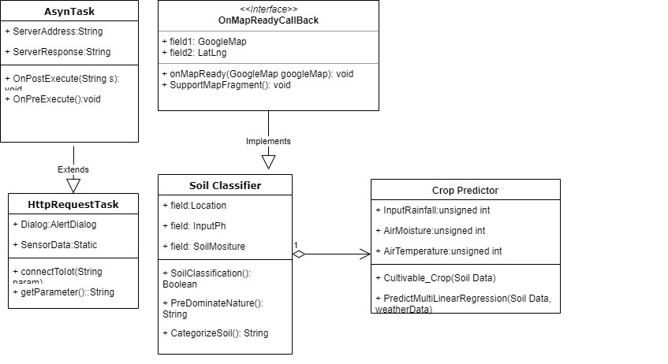

**Sequence Diagram**

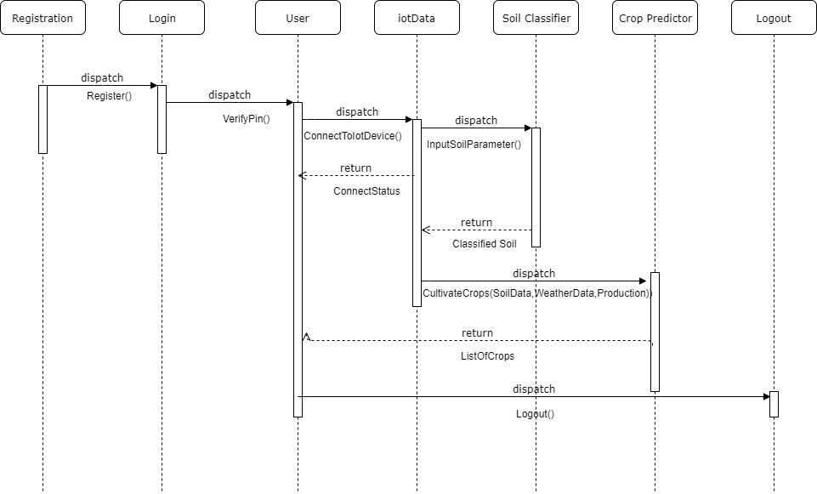

**Use Case Diagram**

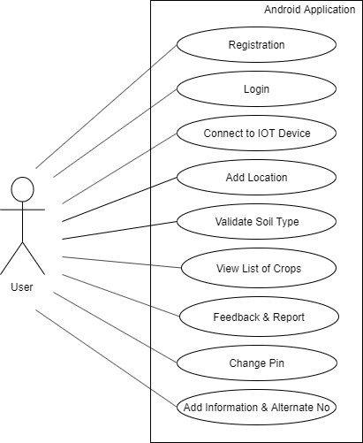

## 5.IMPLEMENTATION

5.1 NodeMCU

With the following Project we required

1. We need to Program the NodeMCU kit and receive the Sensor data.
2. The Received Sensor Data should be send to Amazon Cloud Services.

Setup Arduino IDE for NodeMCU

1. Open the Arduino Software
2. Open the File and click on the Preferences
3. Adding the ESP8266 Board Manager In the Additional Boards Manager enter below URL

<http://arduino.esp8266.com/stable/package_esp8266com_index.json>

1. Download the ESP8266 Board Package. The Boards Manager window opens scroll the window page to bottom till you see the module with the name ESP8266. Once we get it, select that module and select version and click on the Install button
2. Selecting ESP8266 Board in Tools>Board we have to select the Board: “Arduino/Genuino Uno” and then change it to NodeMCU 1.0 (ESP-12E Module)
3. connect the ESP8266 to the PC through USB cable
4. Select COM Port and Upload the Program

5.2 AWS Cloud Services

To Connect the Android Application, Machine learning Platform and IOT Platform we use the Amazon Web Services

Setup AWS Command Line:-

1. Download the AWS CLI Version1 Windows MSI Installer or through pip3 it installawscli package in Windows/Linux.

2. Create an Account in AWS Console and then Sign in.

3. Pay according to required Subscription.

4. Open the AWS Management Console, Go to IAM

5. Create new user give appropriate name. Click Next

6. Give the Administrator access in Policy, Click Next.In Next Page AWS Credentials such as Access key, Secret key.

7. Open Command Shell, enter the command “aws configure” Enter following credentials respectively.

8. Thus, AWS CLI is configured with your AWS account.

5.3 Amplify Framework

AWS Amplify is a development platform for building secure, scalable mobile and web applications. It makes it easy for you to authenticate users, securely store data and user metadata, authorize selective access to data, integrate machine learning, analyze application metrics, and execute server-side code

Setup Amplify CLI:

1. Amplify cli requires the minimum Node Version 8.x and Network Packet Manager (Npm) for the installation of the packages

2. Check installation of Node and Npm through “node -v“ and “npm -v“ respectively in Command Prompt.

3. Enter the command “npm install -g ~~@aws-~~amplify/cli”

4. Configure the Amplify Framework through command “amplify configure”

5. It will pop up the IAM Services in AWS account in your default web browser.

6. Give name to the new user and Click Next

7. Check the Administrator Access to the policy, Click Next

8. It will create the new user with the following AWS Security Credentials

9. Thus, Amplify Framework Command Line get configured in your System.

## 6.SOFTWARE TESTING

**6.1 Unit test cases generation and its testing reports**

|  |  |  |  |  |  |  |  |  |  |
| --- | --- | --- | --- | --- | --- | --- | --- | --- | --- |
| Test case No |  | Test case |  | Input | Expected  Output |  | Actual Output |  | Status |
| 01 |  | Registration |  | Username  Password | Registration successful |  | Registration successful |  | Pass |
| 02 |  | Login |  | Username,  Password | Login successful |  | Login successful |  | Pass |
| 03 |  | User details |  | User details | Data must be store in Dynamo DB |  | Data store into Dynamo DB |  | Pass |
| 04 |  | Send data to cloud |  | Various values through sensors | Data must send to cloud |  | Data send to cloud |  | Pass |
| 05 |  | Receive data on mobile application from cloud |  | Sensor values stored on cloud | Data must be received from cloud on mobile application |  | Data received from cloud on mobile application |  | Pass |
| 06 |  | GPS Location |  | - | Coordinates of Latitude and Longitude of current place must display on mobile application |  | Coordinates of Latitude and Longitude of current place display on mobile application |  | Pass |
| 07 |  | Soil API |  | Current Location | Soil properties must display on mobile application |  | Soil properties display on mobile application |  | Pass |
| 08 |  | Receive predicted crop |  | Various soil properties and Sensor data | Cash crop must be display on mobile application |  | Cash crop displayed on mobile application |  | Pass |

**6.2 Integration test cases generation and its testing reports**

|  |  |  |  |  |  |
| --- | --- | --- | --- | --- | --- |
| Test case No | Test case | Input | Expected  Output | Actual Output | Status |
| 01 | User Authentication in Android through Amplify framework | Correct registered credentials of user( email-id, password) | User must successfully sign-in to android application | User successfully sign-in to android application | Pass |
| 02 | IoT Integration with Android | Various values collected through sensors in particular soil | Values collected through sensors must successfully display on Android application | Values collected through sensors successfully display on Android application | Pass |
| 03 | Soil API integrate with Android | Latitude and Longitude of  current place | Must get correct soil properties and soil class | Get correct soil properties and soil class | Pass |
| 04 | Crop API integrate with Android | Soil properties and soil class | Must predict correct Crop name | Successfully get predicted crop name | Pass |

# 

## 7.SCREENSHOTS

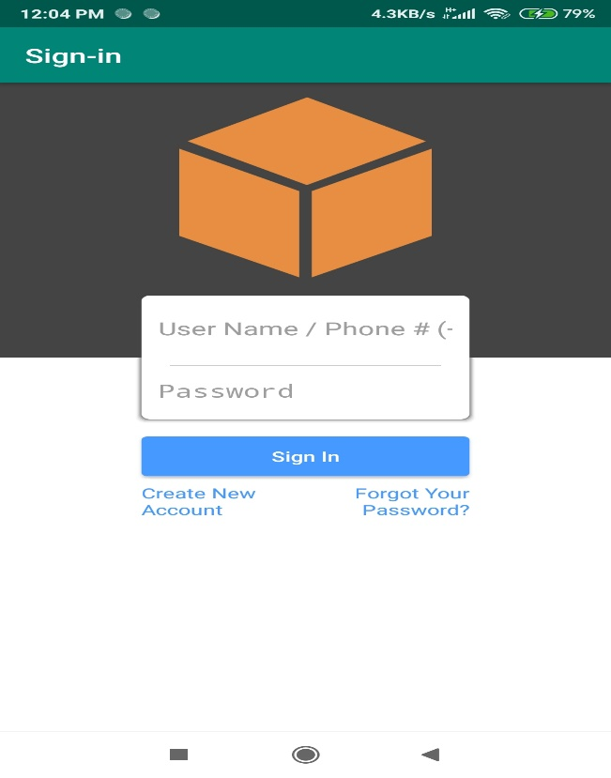

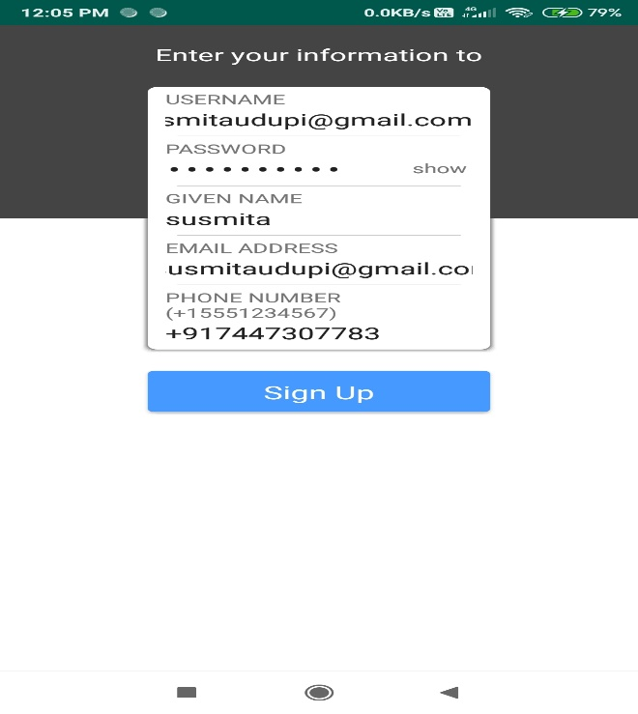

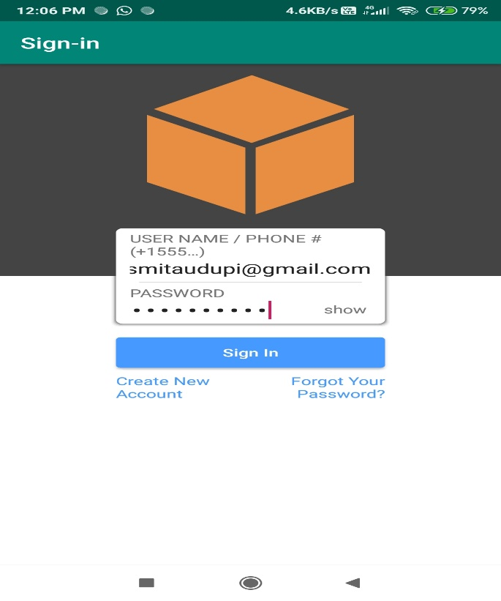

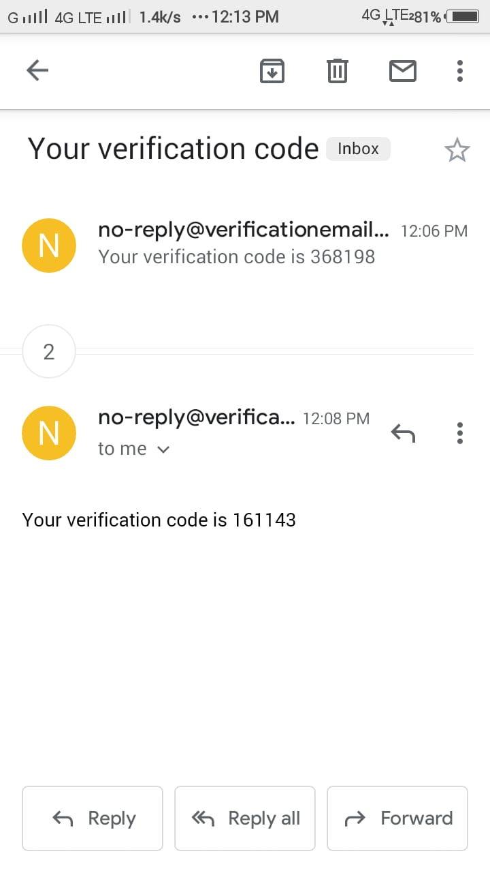

# G:\Ss\5.jpg

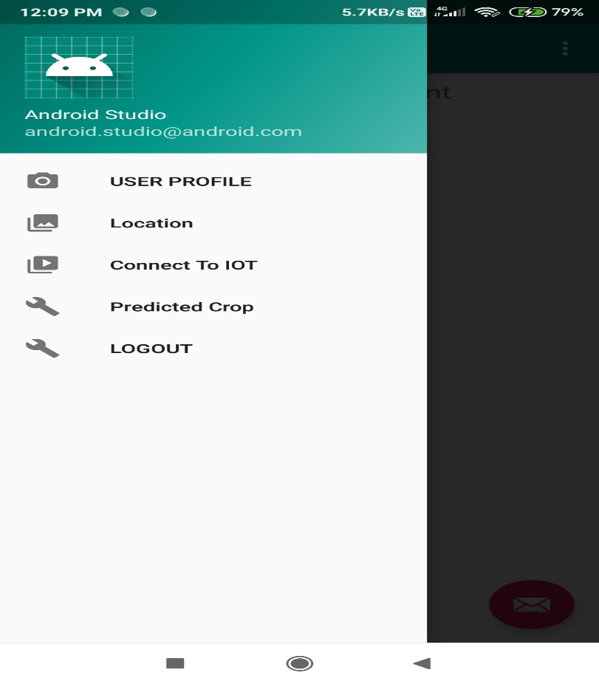

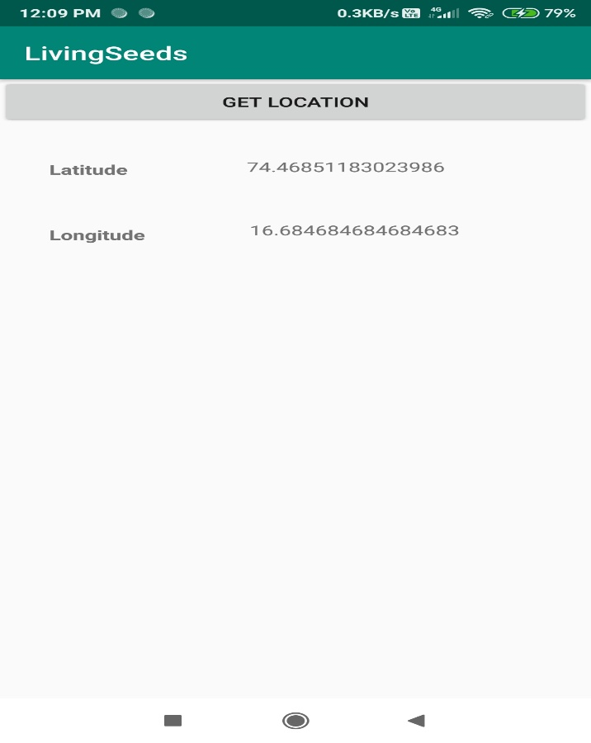

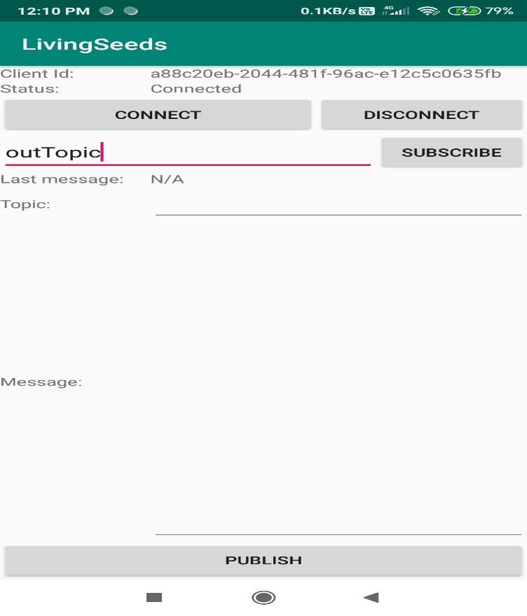

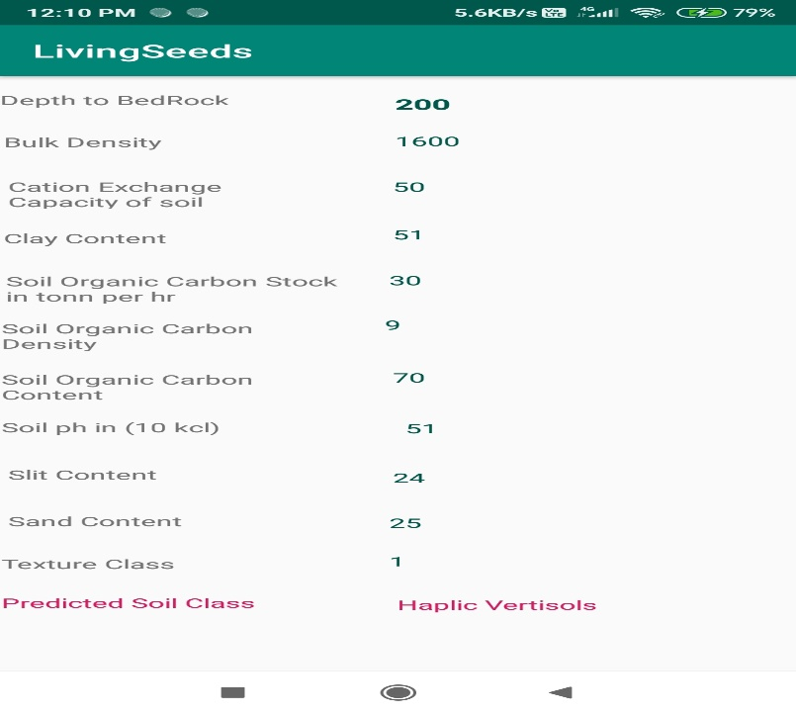

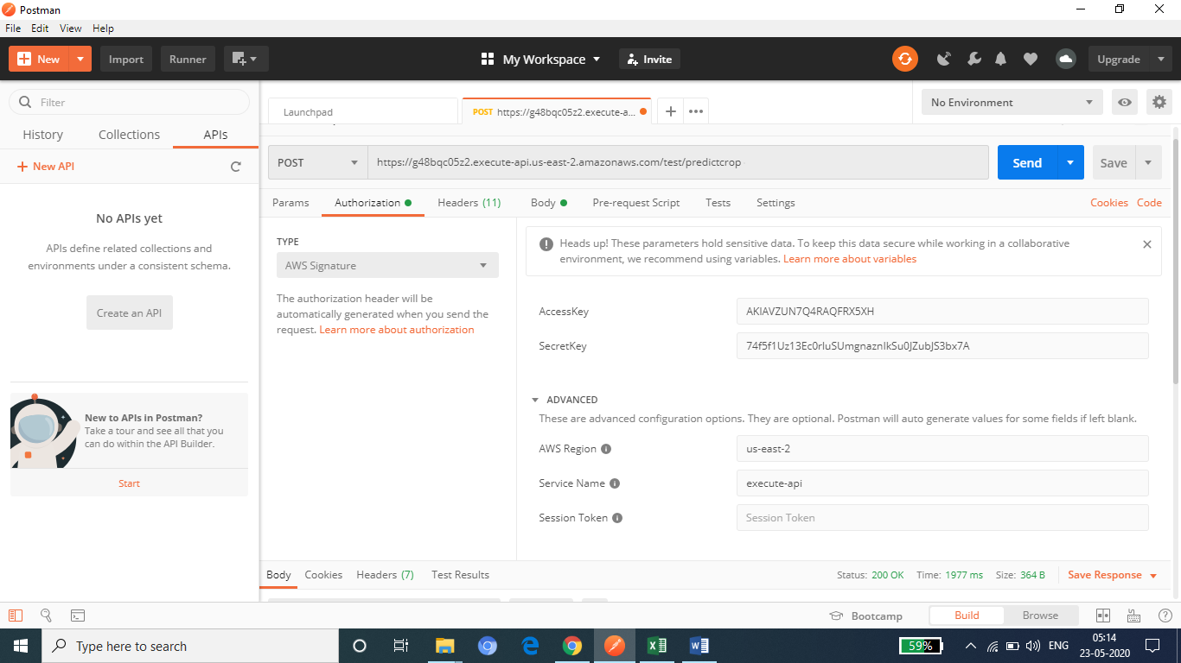

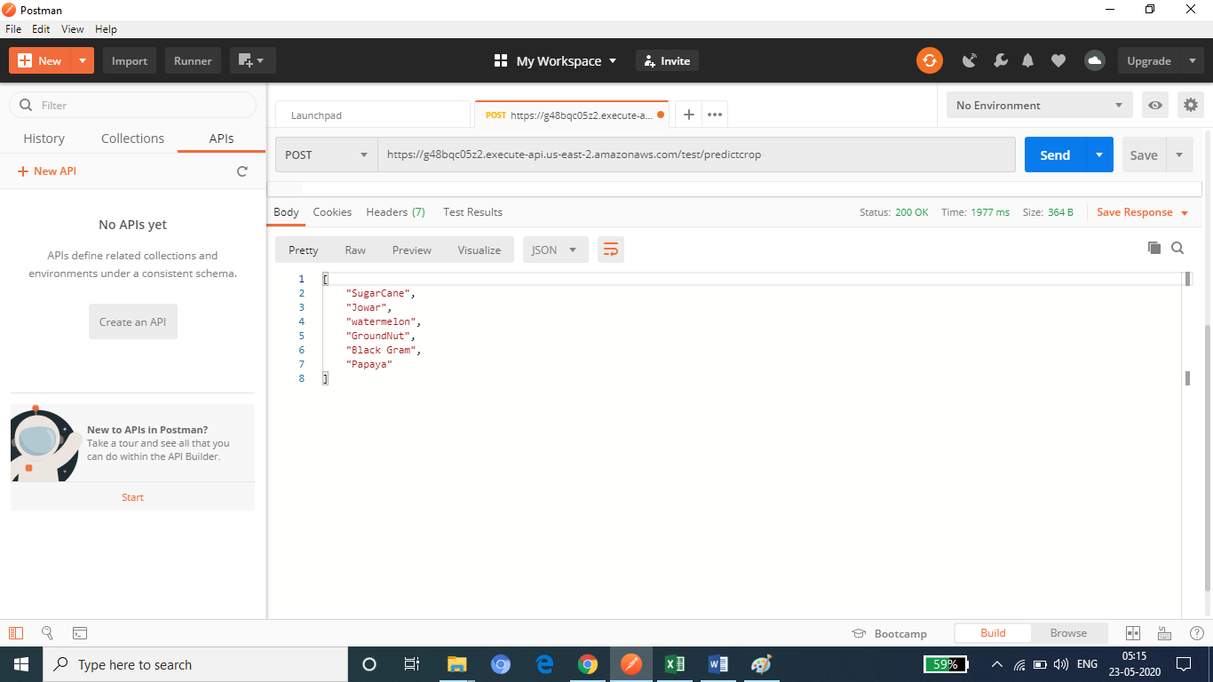

8.PERFORMANCE ANALYSIS

The performance analysis of the project is based on the classification and prediction model. If model predict the output with high accuracy, then system will successfully classify the soil and recommend list of crop.

To integrate IoT devices with android Application and AWS we use aws services like Amplify, PubSub messaging service and IoT core. Using this aws services we get accurate reading of sensors.

For the soil classification task, we have used various samples of soils from different location. The classification task is done through naive bayes algorithm. For the Crop prediction task, we have used different classes of soil and weather conditions. This task is done through linear learner sagemaker algorithm.  
There are 17 classes of soil used to classify the soil and 32 different crops are used to predict the crop. The soil can be classified within these 17 classes and according to the class of soil crop can be predicted from the list of crop.

Overall system gives accuracy between 65% to 85%. Predicted list of crop will be displayed on android application.

# 

## 9. APPLICATION

* Used to specify the fertilizer for the soil.
* Increase the high crop production yield rate
* Maximize the profit for the farmers
* Availability of crops in abundance for the healthy society.
* Uncertainty for the farming is reduce.
* Analysing of resources & infrastructure like Machineries, labourers, for the specific span of time.
* It will reduce excessive chemical usages in crop prediction with the help of precision agriculture

## 10.CONCLUSION

We have built the System that can be used by the farmers to predict the Crop with its respective soil. Crop Prediction in Android Application was successfully developed with fully integration of IOT sensor and Machine Learning Deployed Model.

11. **INSTALLATION GUIDE AND USER MANUAL**

**Installation Steps:**

1. Run .apk file in Android Smartphone.
2. Click Install
3. Sign up the Account.
4. OTP is generated with respective email and Entered Mobile Number.
5. Enter the OTP in Application. Successfully Registered.
6. Login in the Application with entered username or mobile number.

# 12.REFERENCES

[1] Y. Liu, Q. Chen, G. Liu, H. Liu, and Q. Yang, ``EcoSense: A hardware

approach to on-demand sensing in the Internet of Things,'' IEEE Commun. Mag., vol. 54, no. 12, pp. 3743, Dec. 2016.

[2] P. Corcoran, ``Mobile-edge computing and Internet of Things for consumers:

Part II: Energy efciency, connectivity, and economic development,'' IEEE Consum. Electron. Mag., vol. 6, no. 1, pp. 5152, Jan. 2017.

[3] J. Choumert and P. Phélinas, ``Determinants of agricultural land values in

Argentina,'' Ecolog. Econ., vol. 110, pp. 134140, Feb. 2015.

[4] F. Tseng, H. Cho and H. Wu, "Applying Big Data for Intelligent Agriculture- Based Crop Selection Analysis," in IEEE Access, vol. 7, pp. 116965-116974, 2019, doi: 10.1109/ACCESS.2019.2935564.

[5] S. Liu, L. Guo, H. Webb, X. Ya and X. Chang, "Internet of Things Monitoring System of Modern Eco-Agriculture Based on Cloud Computing," in IEEE Access, vol. 7, pp. 37050-37058, 2019, doi: 10.1109/ACCESS.2019.2903720.

[6] A. A. Araby et al., "Smart IoT Monitoring System for Agriculture with Predictive Analysis," 2019 8th International Conference on Modern Circuits and Systems Technologies (MOCAST), Thessaloniki, Greece, 2019, pp. 1-4, doi: 10.1109/MOCAST.2019.8741794.

[7] R. Priya, D. Ramesh and E. Khosla, "Crop Prediction on the Region Belts of India: A Naïve Bayes MapReduce Precision Agricultural Model," 2018 International Conference on Advances in Computing, Communications and Informatics (ICACCI), Bangalore, 2018, pp. 99-104, doi: 10.1109/ICACCI.2018.8554948.

**Git Hub Link :-**

**https://github.com/Riddhi2099/Project**